Electronic Supplementary Information

New Rebek imide-type receptors for adenine featuring acetylene-linked π-stacking platforms†

Raffaella Faraoni,ª Muriel Blanzat,ª Stefan Kubicek,ª Christophe Braun,ª Bernd Schweizer,ª Volker Gramlich^{b} and François Diederichª*
ª Laboratorium für Organische Chemie, ETH-Hönggerberg, CH-8093 Zürich, Switzerland.
E-mail: diederich@org.chem.ethz.ch
^{b} Laboratorium für Kristallographie, ETH-Zentrum, Sonneggstrasse 5, CH-8092 Zürich, Switzerland.

I. Synthesis ESI

Synthesis of 10:
PCC (12.4 g, 57.7 mmol) was suspended in dry CH₂Cl₂ (32 ml), and a solution of imide alcohol (8.67 g, 38.5 mmol) in CH₂Cl₂ (32 ml) was rapidly added at r.t. The mixture turned black becoming homogeneous, then a black solid deposited on the walls of the flask. The mixture was stirred for 3 h. CH₂Cl₂ was partially evaporated and Et₂O added. The solution was decanted and the black solid washed a few times with Et₂O, becoming a granular solid. The decanted solution, combined with the Et₂O washings, was filtered through a plug (SiO₂; CH₂Cl₂/Et₂O 1:1) to afford 10 as a white solid (7.23 g, 84%), mp 168 °C; ν_{max}(neat)/cm⁻¹ 3214w, 3090w, 2966w, 2925w, 2863w, 1700s, 1447m, 1377m, 1313m, 1204s; δ_{H}(300 MHz, CDCl₃) 9.34 (1 H, s), 7.50 (1 H, br s), 2.51 (2 H, d, J 16.5), 1.99 (1 H, d, J 13.5), 1.41 (1 H, d, J 13.5), 1.31-1.26 (8 H, m), 0.99 (3 H, s); δ_{C}(75 MHz, CDCl₃) 202.77, 176.25, 46.51, 43.75, 42.24, 40.17, 26.19, 24.66; HR-FT-MALDI-MS (DHB) calcd for C₁₂H₁₇NO₃Na⁺ ([M+Na]⁺): 246.1101; found: 246.1098.

Synthesis of 11:
To a suspension of NaH (60% in mineral oil, 1.14 g, 47.6 mmol) in dry DMF (169 ml), 10 (7.23 g, 32.4 mmol) in dry DMF (25 ml) was added at 0 °C under N₂. After 30 min, PMBCl (6.1 g, 38.8 mmol) was added dropwise at 0 °C followed by NaI (0.5 g, 3.4 mmol). The mixture was stirred at 0 °C for 2 h and allowed to warm to r.t. overnight. The solution was neutralised with AcOH, poured into ice-water and extracted with AcOEt. The combined organic phases were dried (Na₂SO₄) and concentrated to dryness. FC (SiO₂; CH₂Cl₂/Et₂O 10:1) yielded 11 as a white powder (9.42 g, 85%), mp 136 °C; ν_{max}(neat)/cm⁻¹ 2961w, 2940w, 1721s, 1677s, 1504s, 1457s, 1328s, 1240s, 1163s, 1029s, 1003s, 807s; δ_{H}(300 MHz, CDCl₃) 9.14 (1 H, s), 7.23 (2 H, d, J 8.4), 6.76 (2 H, d, J 8.4), 4.57 (2 H, s), 3.73 (3 H, s), 2.44 (2 H, d, J 14.4), 1.85 (1 H, d, J 13.5), 1.37-1.20 (9 H, m), 0.94 (3 H, s); δ_{C}(75 MHz, CDCl₃) 202.33, 175.98, 158.61, 130.44, 129.22, 113.53, 55.19, 46.27, 42.92, 42.54, 42.41, 40.21, 25.79, 25.66; HR-FT-MALDI-MS (DHB) calcd for C₂₀H₂₅NO₄Na⁺ ([M+Na]⁺): 366.1676; found: 366.1673; EA calcd for C₃₀H₂₅NO₄ (343.42): C 69.95, H 7.34, N 4.08; found: C 69.82; H 7.23, N 4.06.

Deprotection of 13:
Compound 13 (0.48 g, 1.03 mmol) was suspended in CH₃CN (66.4 ml). CAN (2.82 g, 5.14 mmol) and H₂O (6.6 ml) were added and the resulting orange solution stirred at r.t. for 20 h. The mixture was diluted with H₂O and extracted with AcOEt (3 x). The combined organic phases were washed with saturated aq. NaHCO₃, 40% aq. NaHSO₃ and dried (MgSO₄). Concentration under reduced pressure afforded a yellow-white solid. FC (SiO₂; gradient elution: CH₂Cl₂/Et₂O 10:0.4, then CH₂Cl₂/MeOH 10:0.1) afforded a yellow-white solid, that was treated with AcOEt to yield 6 as a white powder (256 mg, 72%), mp 252-253 °C; ν_{max}(neat)/cm⁻¹ 3018w, 2971w, 2920w, 2822w, 2356w, 1695s, 1491m, 1552m, 1354m, 1217s, 1197s; δ_{H}(300 MHz, CDCl₃) 8.76 (1 H, d, J 2.1), 8.63 (1 H, s), 8.12 (1 H, d, J 8.4), 8.01 (1 H, s), 7.65 (1 H, ddd, J 8.4, 6.9, 1.5), 7.58 (1 H, d, J 7.8), 7.43 (1 H, dd, J 7.8, 6.9), 2.35 (2 H, d, J 12.6), 2.13 (1 H, d, J 12.9), 1.44-1.32 (12 H, m); δ_{C}(75 MHz, CDCl₃) 177.71, 152.02, 146.68, 138.80, 129.99, 129.35, 127.62, 127.23, 117.25, 97.20, 80.09, 48.23, 44.49, 40.52, 33.03, 31.46, 25.21; HR-FT-MALDI-MS (DHB) calcd for C₂₂H₂₃N₂O₂⁺ (MH⁺): 347.1754; found: 347.1758; EA calcd for C₂₂H₂₂N₂O₂ (346.43): C 76.28, H 6.40, N 8.09; found: C 76.08; H 6.49, N 7.88.

Synthesis of 14:
Alkyne 8 (1 g, 2.95 mmol) and 8-iodo-9-propyladenine (884 mg, 2.92 mmol) were added into a pressure-resistant Schlenk flask, previously dried and evacuated by N₂-pump cycles. THF (24 ml) was added, the solution degassed by three freeze-pump-thaw cycles and [Pd(PPh₃)₂Cl₂] (102 mg, 5 mol%), CuI (55.5 mg, 10 mol%) and ^{i}Pr₂NH (8 ml) were added under N₂. The mixture was degassed by four freeze-pump-thaw cycles and stirred at 50 °C for 18 h. Upon cooling to r.t., Et₂O was added and the ammonium salt precipitated. The solution was filtered and concentrated to dryness. FC (SiO₂; CH₂Cl₂/MeOH 10:0.4) afforded 14 (1.36 g, 90%) as a white solid, mp ≥ 226 °C (dec.); ν_{max}(neat)/cm⁻¹ 3116br, 2962w, 2928w, 2357w, 1710w, 1669s, 1634s, 1590s, 1508s, 1459s, 1380m, 1320s, 1293s, 1239s, 1160s, 1110m; δ_{H}(300 MHz, CDCl₃) 8.34 (1 H, s), 7.20 (2 H, d, J 8.7), 6.71 (2 H, d, J 8.7), 6.20 (2 H, s), 4.66 (2 H, s), 4.16 (2 H, t, J 7.2), 3.70 (3 H, s), 2.31 (2 H, d, J 12.6), 1.96 (1 H, d, J 13.2), 1.87 (2 H, m), 1.43-1.29 (12 H, m), 0.96 (3 H, t, J 7.2); δ_{C}(75 MHz, CDCl₃) 176.74, 158.89, 155.61, 153.91, 149.90, 134.59, 130.58, 129.70, 119.90, 113.83, 100.74, 71.86, 55.37, 47.87, 45.36, 42.95, 42.76, 40.55, 33.08, 31.72, 26.15, 23.32, 11.48; HR-FT-MALDI-MS (DHB) calcd for C₂₉H₃₅N₆O₃⁺ (MH⁺): 515.2765; found: 515.2770; calcd for C₂₉H₃₄N₆O₃Na⁺ ([M+Na]⁺): 537.2585; found: 537.2586.

Deprotection of 14:
Compound 14 (728.7 mg, 1.41 mmol) was suspended in CH₃CN (90.9 ml). CAN (3.88 g, 7.08 mmol) and H₂O (9.1 ml) were added and the resulting orange solution stirred at r.t. for 20 h. The mixture was diluted with H₂O and extracted with AcOEt (3 x). The combined organic phases were washed with saturated aq. NaHCO₃, 40% aq. NaHSO₃ and dried (MgSO₄). Concentration under reduced pressure afforded a yellow-white solid. FC (SiO₂; gradient elution: AcOEt/Hexane 95:25, then AcOEt/MeOH 5%) afforded a yellow-white solid, that was treated with AcOEt to yield 7 as a white powder (490 mg, 88%), mp ≥ 332 °C (dec.); ν_{max}(neat)/cm⁻¹ 3307w, 3178w, 2971w, 2930w, 2821br, 1692s, 1641s, 1594m, 1571m, 1460m, 1357m, 1219s, 1199m; δ_{H}(300 MHz, CDCl₃) 13.20 (1 H, br s), 8.20 (1 H, s), 4.00 (2 H, t, J 7.5), 2.33 (2 H, d, J 13.2), 2.15 (1 H, d, J 12.9), 1.71 (2 H, m), 1.45-1.33 (12 H, m), 0.88 (3 H, t, J 7.5); δ_{C}(75 MHz, CDCl₃) 179.49, 154.97, 152.04, 148.34, 134.55, 118.20, 99.73, 72.31, 47.70, 44.75, 44.04, 40.21, 32.88, 31.62, 24.95, 23.29, 11.49; HR-FT-MALDI-MS (DHB) calcd for C₂₁H₂₇N₆O₂⁺ (MH⁺): 395.2190; found: 395.2186; EA calcd for C₂₁H₂₆N₆O₂ (394.48): C 63.94, H 6.64, N 21.30; found: C 63.83; H 6.59, N 21.20.

II. Binding Studies ESI
Determination of the association constants K_{a} and the dimerisation constants K_{dim}
¹H-NMR titrations and dilution experiments were performed at 295 K on a Varian Gemini 300 Spectrometer (300 MHz) in CDCl₃ (stored over 4 Å molecular sieves) purchased from Glaser, Basel. The receptor concentration (6) was kept constant at 5 mm, and a solution of 5 (50 mm) was added in increments by syringe into the NMR tube. The change in chemical shift of the imide N–H proton was recorded after each of 12-14 additions. Binding isotherms were created using the NMRTit HG HH GG software¹ on an Apple Macintosh computer. Values reported are the average of 3 independent runs. Uncertainty listed in K_{a} is one standard deviation from triplicate runs. Dilution experiments were carried out with a solution of 6 (50 mm) that was progressively diluted with CDCl₃. The change in chemical shift of the imide N–H proton was recorded after each of 8-9 CDCl₃ additions. Dilution curves and K_{dim} values were obtained using the NMRDil Dimer software¹ on an Apple Macintosh computer. Values reported are the average of 2-3 independent runs. Uncertainty listed in K_{dim} is one standard deviation from duplicate or triplicate runs.

Determination of thermodynamic parameters by van’t Hoff analysis
Van’t Hoff plots were generated by measuring the chemical shift response of the receptor imide N–H proton to temperature given a fixed concentration of receptor 6 (10 mm) and 5 (20 mm). The assumption of a temperature-independent chemical shift for the fully complexed imide N–H proton was made. The initial solution concentrations were chosen such that 20-80% of the saturation curve was sampled. Samples were equilibrated for 30-45 minutes initially (258 K), for 10-15 minutes between 258-303 K, and for 5 minutes thereafter until the maximum temperature was obtained (323K).

The K_{a} values were calculated as follows. K_{a} = ([host•guest]/[host][guest]) where [host•guest] = ([6]_{tot}) (δ_{obs}-δ_{r})/(δ_{6•5}-δ_{r}), [6]_{tot}= the total concentration of 6 in solution, δ_{obs} = observed chemical shift, δ_{r} = chemical shift of the imide N–H group of 6, δ_{6•5} = chemical shift of the N–H group of 6 in the 6•5 complex (estimated on the basis of NMR titration data). Values reported are the average of 2-3 independent runs.

Determination of the binding stoichiometry by Job plot analysis
The 1:1 binding stoichiometry of the 6•5 complex was confirmed as follows. Two stock solutions were prepared; solution A: 5 mm of 6 in CDCl₃. Solution B: 5 mm of 5 in CDCl₃. Ten 5-mm NMR tubes were filled with solutions A and B in the following volume ratios: 50:450, 100:400, 150:350, 200:300, 250:250, 300:200, 350:150, 400:100, 450:50, and 500:0 μL. ¹H NMR spectra were recorded at 300 MHz for each mixture. The concentration of the 6•5 complex was estimated as reported above. The experiments were repeated 2-3 times to ensure accuracy.

Figure ESI 1 ¹H NMR titration to determine the stability of complex 6•5 at 295 K in CDCl₃.
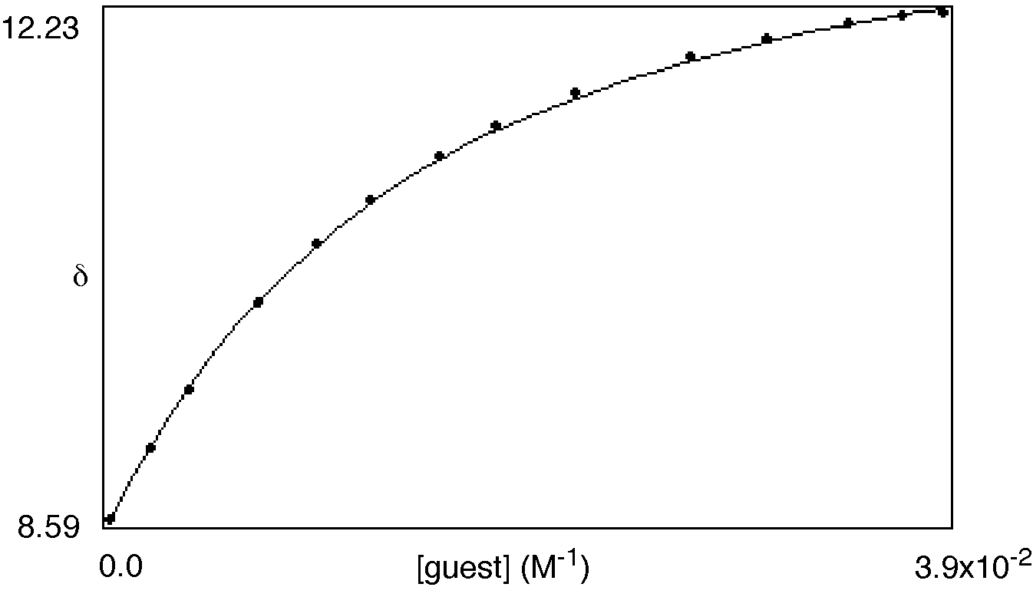
K_{a} = 122m⁻¹, [6] = 5mm
δ_{bound} = 13.851 [5] = 50mm
δ_{dimer} fix = 12.221
δ_{dimer} dil = 12.420
ss of residuals = 6.19476987049•10⁻³
R factor = 0.513%
Min % bound = 16%
Max % bound = 74%

Figure ESI 2 Dilution curve of 6 in CDCl₃.
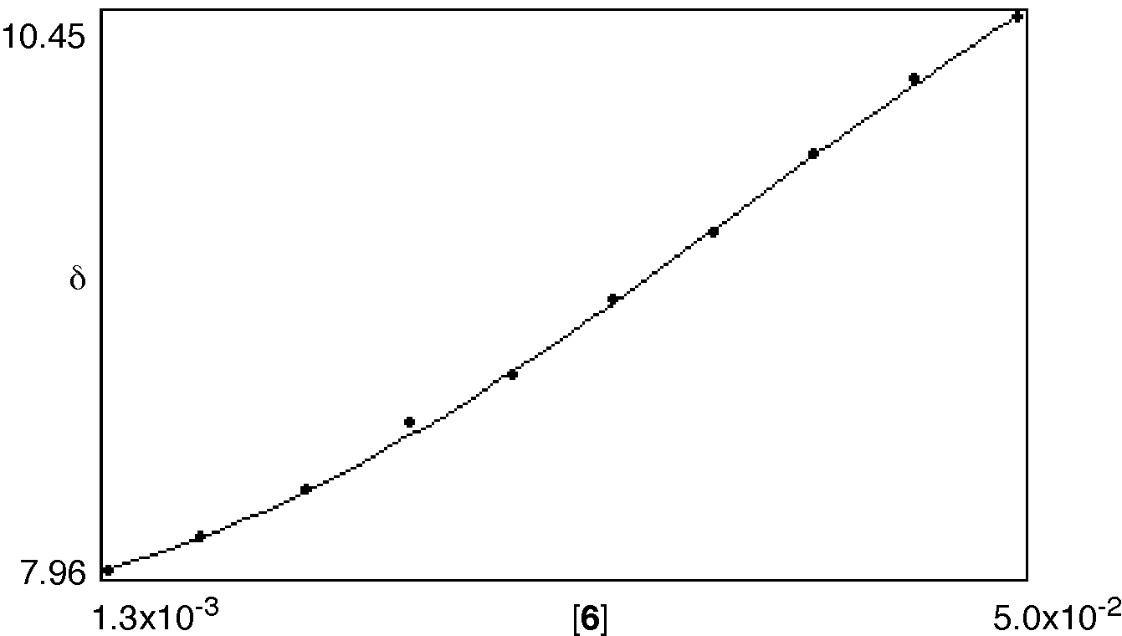

K_{d} = 38.1m⁻¹
δ_{bound} = 12.362
δ_{free} = 7.570
ss of residuals = 3.71160241775•10⁻³
R factor = 0.853%
Min bound = 8%
Max bound = 60%
Figure ESI 3 Van’t Hoff plot to determine the temperature dependence of the association between 6 and 5 in CDCl₃.
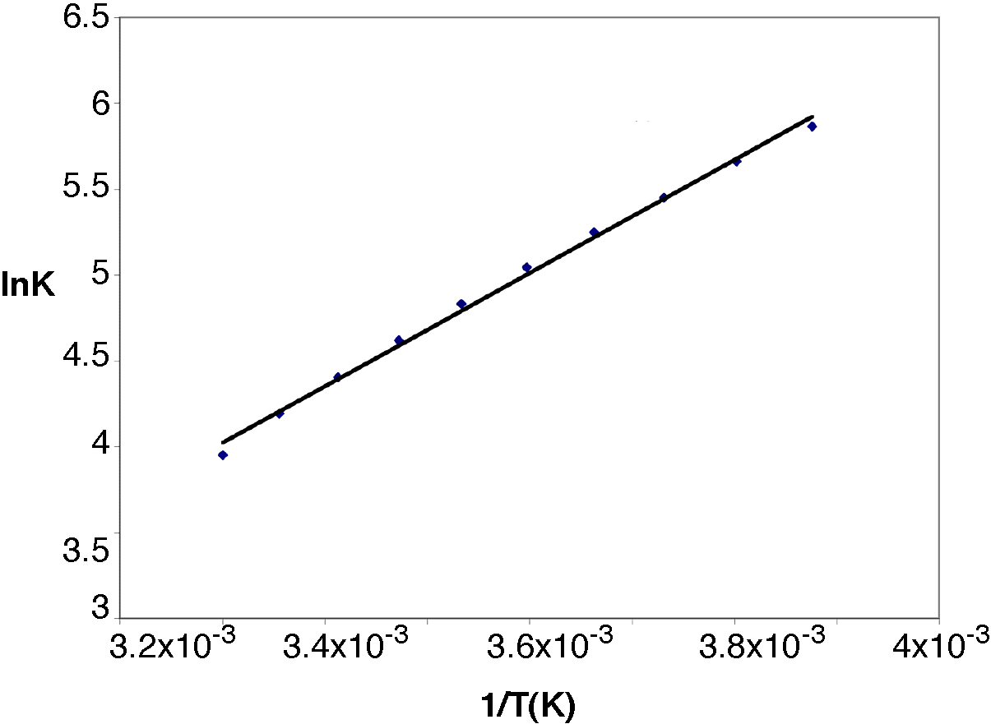

Figure ESI 4 Job plot to prove the 1:1 binding stoichiometry of complex 6•5 in CDCl₃.
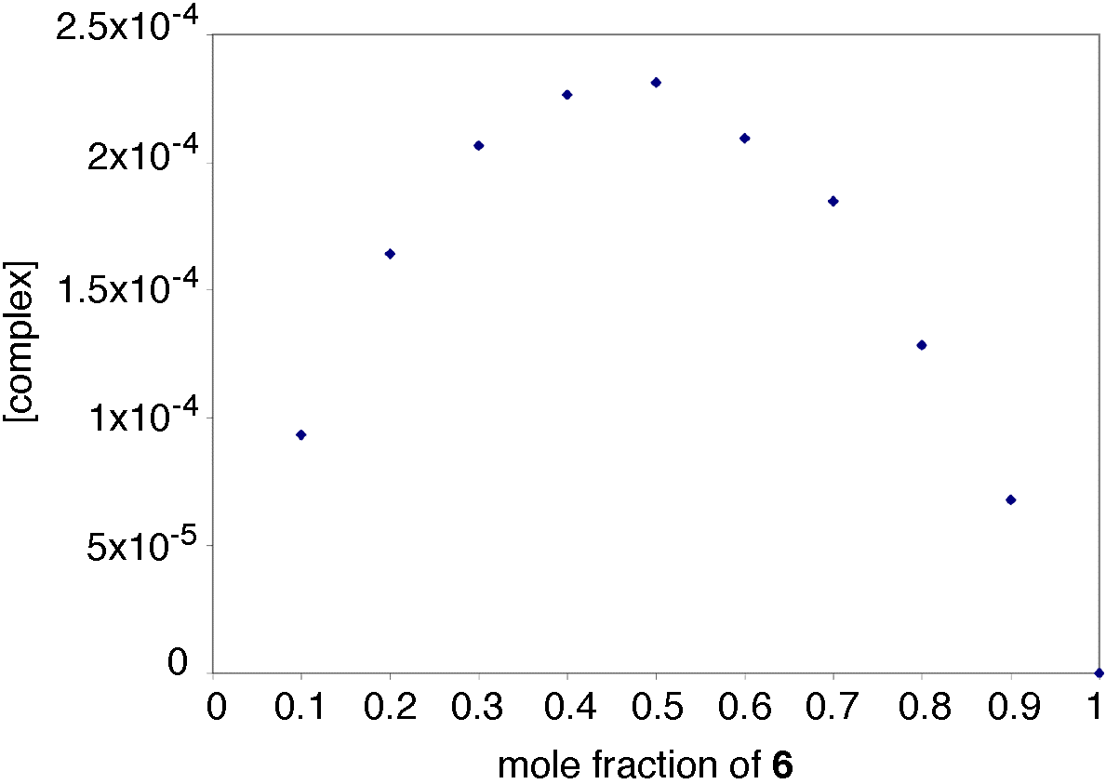

III Crystal data ESI
The data of 6 and 7 were collected on a KappaCCD diffractometer radiation with MoK_{α} radiation (graphite monochromator λ = 0.71073). The structures were solved with the SIR97 (Altomare, 1999) program² and refined by full matrix least-squares on F² with the SHELXL-97 program.³

References ESI
1 A. P. Bisson, C. A. Hunter, J. C. Morales and K. Young, Chem. Eur. J., 1998, 4, 845-851.
2 A. Altomare, M. C. Burla, M. Camalli, G. L. Cascarano, C. Giacovazzo, A. Guagliardi, A. G. G. Moliterni and R. Spagna, J. Appl. Cryst., 1999, 32, 115-119.
3 G. M. Sheldrick, SHELXL-97; Program for the Refinement of Crystal Structures. University of Göttingen, Germany, 1997.

